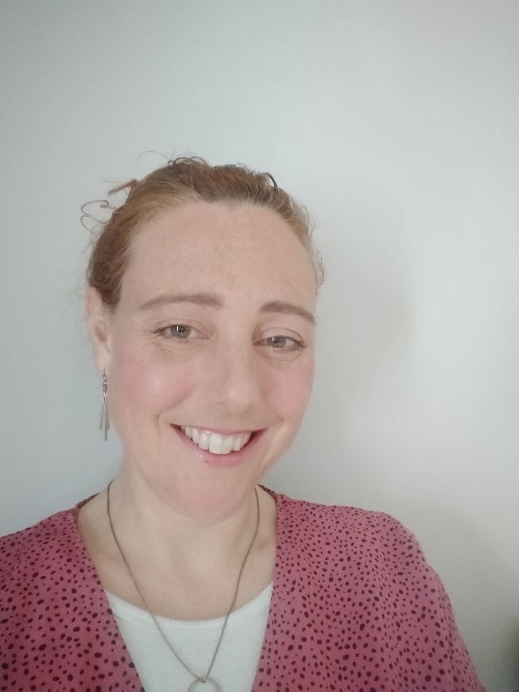Hello my name is Sam Crowe, I am the Employability Key Worker for the Ullapool area. This service is free and provided by the Highland Council

who can I help?

Are you unemployed, a stay at home parent or under employed (e.g working part time when you want to be full time or doing a low skilled job, but think you could do more). Do you feel you have barriers stopping you from getting the work you want? Barriers could be things like low confidence, lack of qualifications and no relevant work experience.

How can I help?

I can offer 1-1 support to work out an action plan that is at pace to suit you, this can include:

* Training
* Gaining the qualifications
* Confidence building
* help to look for work opportunities
* help with CV writing
* Interview experience
* assistance in finding work experience opportunities in the right areas for you

How to contact me-

You are welcome to ring for a chat 0771 155158

Or you can email me [samantha.crowe@highland.gov.uk](mailto:samantha.crowe@highland.gov.uk)

More information on the service can be found at www.highland.gov.uk/info/20014/economic_development/599/employability